FOR MANAGER USE ONLY: | EFFECTIVE DATE:

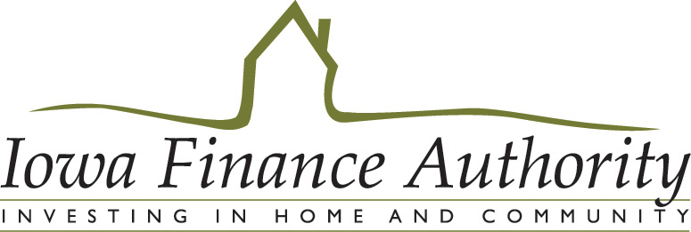

STUDENT STATUS SELF AFFIDAVIT

Project Name: |  | IFA Project # |  | Date:
Applicant/Tenant: |  | SSN: |  | Apt. #:

Check all that apply:

I am currently a student. List name of educational institution: ___________________________________________________
Full-time
Part-time

I have been a student during the current calendar year. List name of educational institution: ___________________________
Full-time
Part-time

I plan on becoming a student in the next 12 months. List name of educational institution: _____________________________
Full-time
Part-time

I have not been a student in the current year and do not expect to become a student in the next 12 months.

Under penalty of perjury, I certify that the information presented in this certification is true and accurate to the best of my knowledge. The undersigned further understand(s) that providing false representations herein constitutes an act of fraud. False, misleading or incomplete information may result in the termination of a lease agreement.

Signature of Applicant/Tenant Printed Name of Applicant/Tenant Date

Subscribed and sworn to me this ______ Day of ______________________, 20_______

(SEAL)
____________________________________
Notary Public

NOTE: Section 1001 of Title 18 of the U.S. Code makes it a criminal offense to make willful false statements or misrepresentations to any Department or Agency of the United States as to any matter within its jurisdiction.

